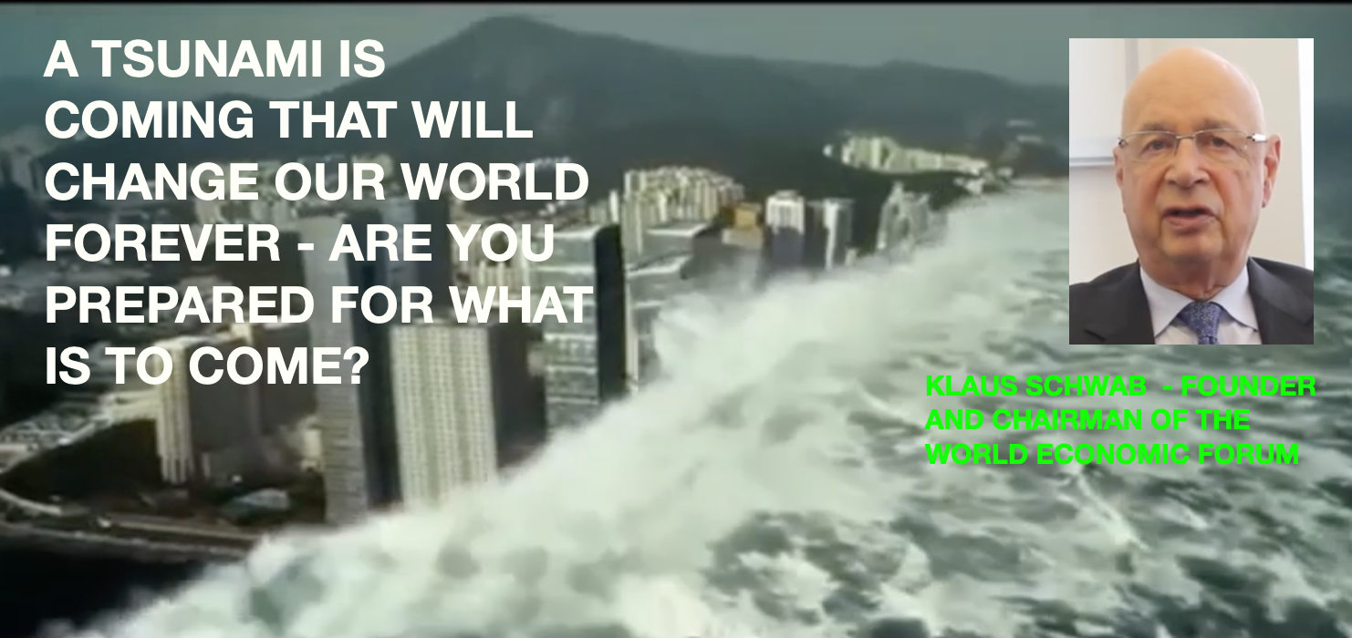
A Global Planned Financial Tsunami has just begun.

Global Research Centre for Research and Globalisation writes on the 23rd July 2022
“The extent of the “cheap credit” bubble that the Fed, the ECB and Bank of Japan have engineered with buying up of bonds and maintaining unprecedented near-zero or even negative interest rates for now 14 years, is beyond imagination. Financial media cover it over with daily nonsense reporting, while the world economy is being readied, not for so-called “stagflation” or recession. What is coming now in the coming months, barring a dramatic policy reversal, is the worst economic depression in history to date. Thank you, globalization and Davos.”

Since I retired as a UK Regulated Financial Adviser just over 14 years ago, I have spoken many times during seminars, conferences and on Christian Television programmes, as well as having written articles and books about the importance of knowing how money is created and the workings behind the world’s monetary system. In fact, in my seminars in 2015 I wrote a small supporting booklet called ‘The Great Last Days Money Deception’ which was published in 2015. On the front cover is a dramatic picture of a tsunami engulfing a village in order to try and bring a sense of urgency.

On the face of it, it seems crazy that something so important would not be included in any curriculum in schools and at a more advanced level in universities, so why would such an important subject be completely ignored?

The Creation of Money out of Nothing
A full answer would take a little while to explain but in simple terms, it is because as long as the masses can be convinced that ‘those in the know’ are looking after such things and all will be well, the illusion about money creation will not be revealed. If the system were to be understood, that money is created literally ‘out of nothing’, which is a massive conjuring trick involving complete manipulation by the ‘Money-Men’, then all confidence would soon be lost. People might then see through the ‘smoke and mirrors, and something previously regarded as far too complicated for the average citizen to possibly understand would come to light. Then the game would be up and honest money would need to be re-created that would require a complete new set of rules that would change everything we thought we knew about how life worked. In reality, when most people do find out and then consider the costs of revealing such a scam, they prefer not to disturb the status quo.

As long as people believe that they need not waste the time and energy in trying to understand and as long as they can go about their lives thinking ‘others in the know’ are looking after their money, the illusion goes on. It is much like the ‘emperor is wearing no clothes’ syndrome. Despite the enormous amount of information fully available that would reveal the truth, it is not sought after and those wielding the power over the people know it.

And so, the illusion goes on and despite people constantly losing savings, investments and pensions in the manipulated market conditions, millions simply continue in wilful ignorance. But this process of thinking will soon cost them dearly when the system finally fails as it is clearly headed towards doing. But, as the saying goes, people are people. I have warned and warned continuously about how this story will have to end but these warnings go unheeded.

The Coming Financial Tsunami
It has felt much like watching people playing on a beach in an exotic country when suddenly an underwater earthquake causes a huge tsunami to develop, just like the one that happened on Christmas eve many years ago near the coast costs of Sumatra creating waves over 30 meters that swept through the shores killing over 200,000 people.

It will be the same when the new money system, years in the preparation, comes into focus. At first, people’s attention will be captured by a strange silence and a kind of peace that lulls them into a false sense of security just like when the tide first goes right out into the distance. But then, the sight of the waves returning with such speed and measuring hundreds of meters high sends them scuppering for safety in their attempts to outrun it. But the power, height and speed of the tsunami overwhelms them. The new money system that is taking place now behind the scenes and the assurances that it will meet our every need will at first present a picture of peace and serenity as those in power describe how it will be the ‘common good’. Then just as we relax, the sheer power with which the new system arrives will overwhelm us and the reality and consequences will be experienced.

What’s behind ‘The Great Reset?’
It was clear, after the collapse of the banks in 2008 that this monetary system, which relies totally on the creation of more and more debt, could not continue indefinitely. Now having created trillions in paper currency of all kinds: dollars, pounds, euros and yen etc, the 100-year age of the debt-based system is finally drawing to a close to make way for the new system. People who do not really understand what has been happening to the world since the World Economic Forum announced its ‘Great Reset’ agenda in July 2020, are very close to finding out. But the revelation will not be pretty or easily accepted at first. Why, because whilst people were diverted over the past two and a half years and focussed on a false pandemic, the world’s Central Banks have been busy behind the scenes and are now much closer to launching their plans for Digital currencies. Once these appear, the need for cash will disappear and quite possibly the savings and investments of millions of people will be wiped out. Hence the now over quoted saying of the World Economic Forum “You will own nothing and be happy’.

However, this is actually what the Great Reset has been about since the very beginning.

Ignoring Continuous Warnings
For years people have been ignoring warnings, choosing rather to believe that governments and bankers have the public interests at heart whilst working in collusion with the mainstream media to convince people that economies are actually in good shape and that better times lie ahead. During this time, major investment groups have continued to promote financial ‘models’ that create the illusion of security.

But now, many articles are making their way into the public awareness, despite the attempts to censor and ignore the warnings. What will it mean for the average man and woman? A rude awakening, I’m afraid and much more besides.

The following two sources bring a deeper awareness and should be taken very seriously. These are just two of a multitude now appearing.

For Christians who ask where is God in all of this?
I would say, He has been here all along but He has allowed us all to follow our own passions and desires and now, we about to reap what we have either sowed or allowed to be sowed. But it’s not too late to admit these things to God and ask him for His forgiveness and then decide to seriously consider whether you wish to go on ignoring Him or to give your lives over to Him. The Bible is clear how God will respond to such people. (John 3:16)

Graham Bridger

